**Schema Diagram**

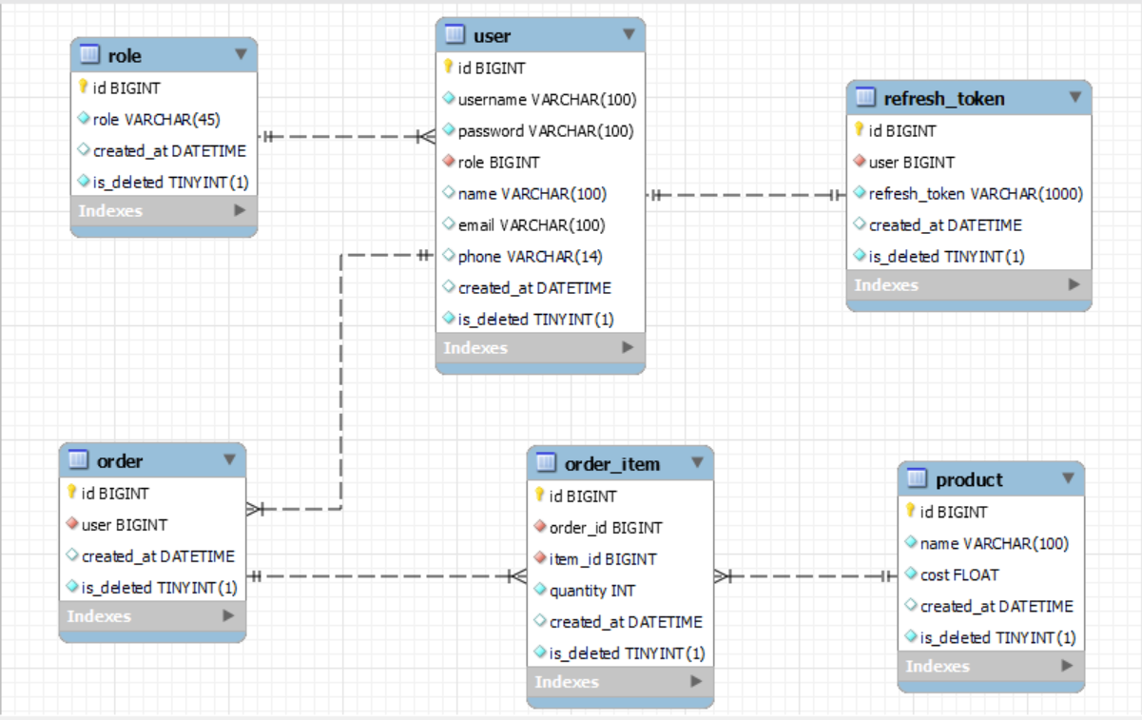

**Data Definition Language (DDL) Statements**

**ROLE** 🡺

CREATE TABLE `user_order_management`.`role` (

`id` BIGINT NOT NULL AUTO_INCREMENT,

`role` VARCHAR(45) NOT NULL,

`created_at` DATETIME DEFAULT CURRENT_TIMESTAMP ON UPDATE CURRENT_TIMESTAMP,

`is_deleted` BOOLEAN NOT NULL DEFAULT false,

PRIMARY KEY (`id`),

UNIQUE INDEX `id_UNIQUE` (`id` ASC) VISIBLE);

**USER** 🡺

CREATE TABLE `user_order_management`.`user` (

`id` BIGINT NOT NULL AUTO_INCREMENT,

`username` VARCHAR(100) NOT NULL,

`password` VARCHAR(100) NOT NULL,

`role` BIGINT NOT NULL DEFAULT 3,

`name` VARCHAR(100) NULL,

`email` VARCHAR(100) NULL,

`phone` VARCHAR(14) NULL,

`created_at` DATETIME DEFAULT CURRENT_TIMESTAMP ON UPDATE CURRENT_TIMESTAMP,

`is_deleted` BOOLEAN NOT NULL DEFAULT false,

PRIMARY KEY (`id`),

UNIQUE INDEX `id_UNIQUE` (`id` ASC) VISIBLE,

UNIQUE INDEX `username_UNIQUE` (`username` ASC) VISIBLE,

INDEX `roleID_idx` (`role` ASC) VISIBLE,

CONSTRAINT `roleID`

FOREIGN KEY (`role`)

REFERENCES `user_order_management`.`role` (`id`)

ON DELETE NO ACTION

ON UPDATE NO ACTION);

**REFRESH TOKEN** 🡺

CREATE TABLE `user_order_management`.`refresh_token` (

`id` BIGINT NOT NULL AUTO_INCREMENT,

`user` BIGINT NOT NULL,

`refresh_token` VARCHAR(1000) NOT NULL,

`created_at` DATETIME DEFAULT CURRENT_TIMESTAMP ON UPDATE CURRENT_TIMESTAMP,

`is_deleted` BOOLEAN NOT NULL DEFAULT false,

PRIMARY KEY (`id`),

UNIQUE INDEX `id_UNIQUE` (`id` ASC) VISIBLE,

INDEX `userID_idx` (`user` ASC) VISIBLE,

CONSTRAINT `userID`

FOREIGN KEY (`user`)

REFERENCES `user_order_management`.`user` (`id`)

ON DELETE NO ACTION

ON UPDATE NO ACTION);

**ORDER** 🡺

CREATE TABLE `user_order_management`.`order` (

`id` BIGINT NOT NULL AUTO_INCREMENT,

`user` BIGINT NOT NULL,

`created_at` DATETIME DEFAULT CURRENT_TIMESTAMP ON UPDATE CURRENT_TIMESTAMP,

`is_deleted` BOOLEAN NOT NULL DEFAULT false,

PRIMARY KEY (`id`),

UNIQUE INDEX `id_UNIQUE` (`id` ASC) VISIBLE,

INDEX `userID_idx` (`user` ASC) VISIBLE,

CONSTRAINT `user_id`

FOREIGN KEY (`user`)

REFERENCES `user_order_management`.`user` (`id`)

ON DELETE NO ACTION

ON UPDATE NO ACTION);

**PRODUCT** 🡺

CREATE TABLE `user_order_management`.`product` (

`id` BIGINT NOT NULL AUTO_INCREMENT,

`name` VARCHAR(100) NOT NULL,

`cost` FLOAT NOT NULL,

`created_at` DATETIME DEFAULT CURRENT_TIMESTAMP ON UPDATE CURRENT_TIMESTAMP,

`is_deleted` BOOLEAN NOT NULL DEFAULT false,

PRIMARY KEY (`id`),

UNIQUE INDEX `id_UNIQUE` (`id` ASC) VISIBLE);

**ORDER ITEM** 🡺

CREATE TABLE `user_order_management`.`order_item` (

`id` BIGINT NOT NULL AUTO_INCREMENT,

`order_id` BIGINT NOT NULL,

`item_id` BIGINT NOT NULL,

`quantity` INT NOT NULL,

`created_at` DATETIME DEFAULT CURRENT_TIMESTAMP ON UPDATE CURRENT_TIMESTAMP,

`is_deleted` BOOLEAN NOT NULL DEFAULT false,

PRIMARY KEY (`id`),

UNIQUE INDEX `id_UNIQUE` (`id` ASC) VISIBLE,

INDEX `orderID_idx` (`order_id` ASC) VISIBLE,

INDEX `itemID_idx` (`item_id` ASC) VISIBLE,

CONSTRAINT `orderID`

FOREIGN KEY (`order_id`)

REFERENCES `user_order_management`.`order` (`id`)

ON DELETE NO ACTION

ON UPDATE NO ACTION,

CONSTRAINT `itemID`

FOREIGN KEY (`item_id`)

REFERENCES `user_order_management`.`product` (`id`)

ON DELETE NO ACTION

ON UPDATE NO ACTION);